Title: CST 370 Programming Assignment 1

Author: Julia Diliberto

Date: January 10, 2016

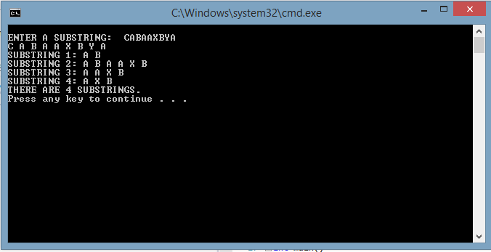

This screenshot shows the results of input with four substrings that fit the requirements.

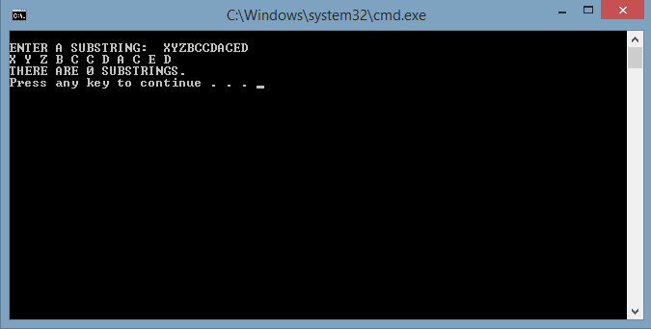

This screenshot shows the results with no substrings that fit the requirements.